# ECE 162 Week 9 – Op Amp

Name: Brian Loughran (btl217@lehigh.edu)

## Purpose

In this lab we will study the op amp as a linear amplifier, and in saturation.

## Theory

Op-amps, or operational amplifiers, are a high gain electronic voltage amplifier. This means that it can take small voltages and convert them to bigger voltages while connected to a power source. They can produce output potential as much as hundreds of thousands of times larger than potential between its input terminals.

One practical use for an operational amplifier which we have seen in the Lehigh curriculum is in the strain gage which we analyzed in our first mechanical engineering lab. Strain gages work by bonding the gage to a rigid structure. When strain is applied to the structure, the resistance of the gage is changed slightly. Because of the small magnitudes of this change, only a small change in voltage can be measured. Inclusion of an op-amp in this system makes it far easier to measure this change, as it magnifies that change to a far easier to read level.

In this lab we are analyzing a simple op-amp system. The circuit diagram for our lab is shown below in Figure 1:

Figure 1

This figure shows several things. The first is the input voltage (V1) and the output voltage (V0). Because we are analyzing a traditional op-amp system with constant values for resistance, the output voltage is a function only of input voltage. The output voltage for this system is far greater than the input voltage, as we will explore later.

Also included are the resistance values. The first value (R1) is the input resistance, and has a value of 10 Ω. The second resistor (Rf) is called the feedback resistor, and has a value of 100 Ω. Using these values, we can find the relationship between input and output voltages, also called the gain. This equation is shown below:

$$V_{0}= -\frac{R_{f}}{R_{1}} V_{f} (eq.1)$$

Plugging in our values for resistance, we find that the gain of the system has a unit less value of -10. This also means that the output voltage be opposite sign from the input voltage, with a magnitude of 10 times the input voltage.

## Experimental Method

* Build the circuit from Figure 1 with correct values for resistance
* Connect input voltage of .25V
* Measure output voltage and plot both waveforms of the same plot
* Repeat previous steps for input voltages of .5V and 2V

## Diagram

A more detailed version of the circuit which we are creating is shown below in Figure 2 below. This figure shows the different ports on the op-amp, as well as the voltage applied across the op-amp. Figure 2 is shown below:

Figure 2

Shown below is a figure describing our LabView block diagram. This is very similar to the LabView VI which we used in the previous week, as in this lab we are again plotting two waveforms on the same plot. This requires two inputs for the sampling rate. The block diagram is included below in Figure 3:

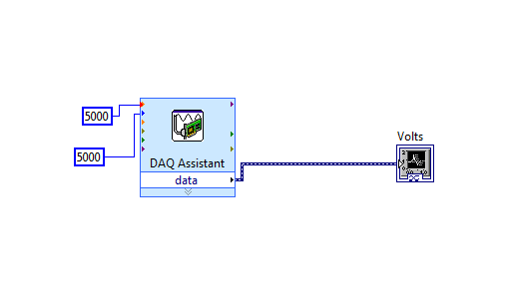

Figure 3

## Results

Moving systematically through each trial which we had to measure, we will begin with the .25V input. Considering a gain of 10, the output voltage should be around 2.5V. The figure showing both waveforms is shown below (Figure 4):

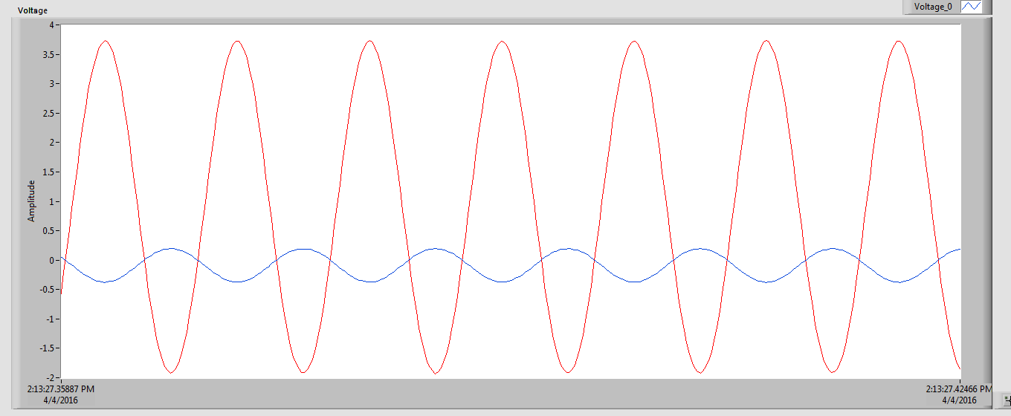

Figure 4

The blue line (much smaller magnitude) is the input voltage, and the red line (much larger magnitude) is the output voltage. As you can see, while the input voltage is at a minimum the input voltage is at a maximum, and vice versa. This accentuates the fact that the gain is negative, and changes the sign of the output voltage.

Also of note are the magnitudes of voltage for the op-amp. Table 1 below shows these magnitudes:

|  |  |  |  |
| --- | --- | --- | --- |
| V1 (Volts | V0 (Volts) | Voltage Gain | Is amplification linear? |
| 0.288 | 2.8 | 9.72 | yes |

Table 1

Some things of note for this data set: First you may notice that the input voltage is not exactly .25V. This is because of the sensitivity of the instruments which we were using to create the input voltages. 0.288V was as close as we could get to 0.25V, and considering the arbitrary nature of the number 0.25, we decided the net effect of the op-amp could be effectively measured and recorded even with this slight error.

The next item which we can discuss is linear amplification (last column). This simply states that the output voltage is a linear function of the input voltage. This will be the case as long as the output voltage is not greater than the voltage applied to the op-amp. If the gain puts the output voltage above the voltage supplied to the op-amp, the output voltage will simply cap at the supplied voltage. This will be shown in another example, but amplification is linear for this first case

Next we can analyze the case for the 0.5V input voltage. Shown below is a figure showing the input voltage and output voltage waveforms (Figure 5):

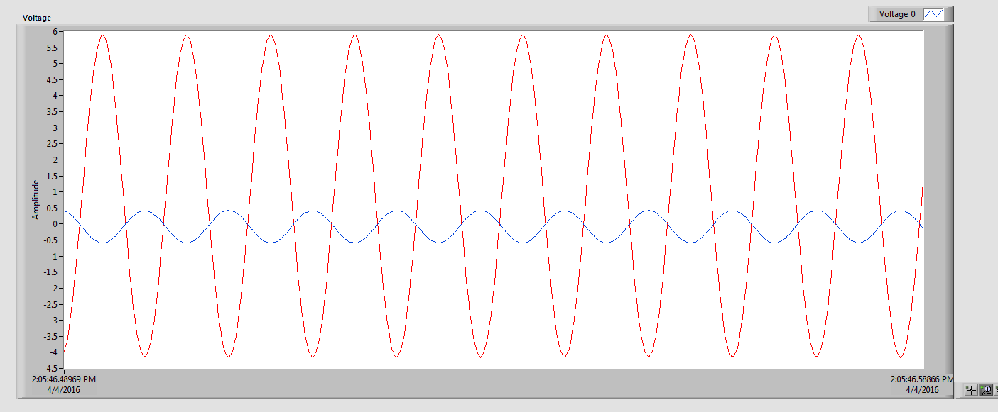

Figure 5

Apart from the magnitudes of the voltages, this waveform looks incredibly similar to the previous waveform. Again, the blue line (much smaller magnitude) is the input voltage, and the red line (much larger magnitude) is the output voltage.

Below is a table showing the magnitudes of the voltages for the 0.5V case (Table 2):

|  |  |  |  |
| --- | --- | --- | --- |
| V1 (Volts | V0 (Volts) | Voltage Gain | Is amplification linear? |
| 0.5 | 5.15 | 10.3 | yes |

Table 2

The magnitudes of the voltages tell a similar story to those in table 1, and the amplification is again linear. Next we will look at an example where linear amplification is not linear.

Below is the waveform for the case of applying 2V input voltage. This is shown in Figure 6:

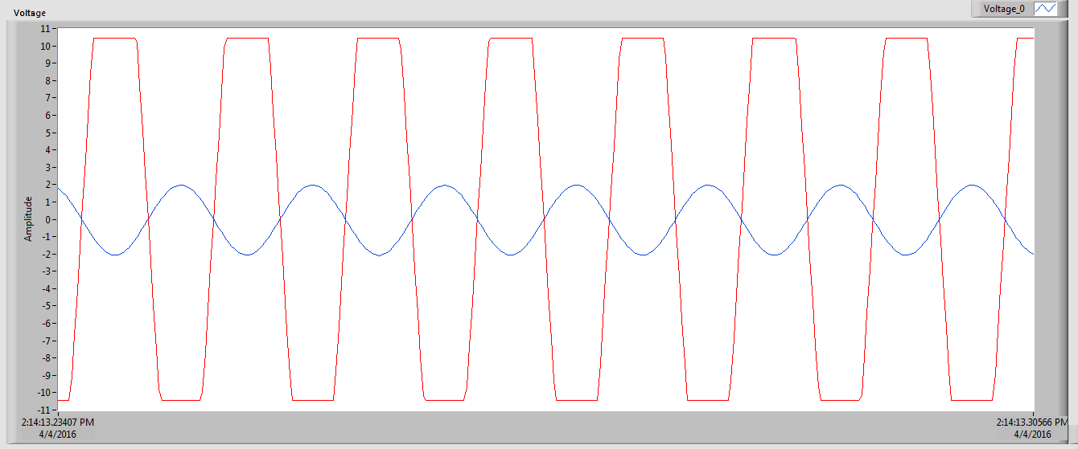

Figure 6

As you can see, this waveform is a bit different form the first two. The magnitudes of the voltage are shown below in table 3:

|  |  |  |  |
| --- | --- | --- | --- |
| V1 (Volts | V0 (Volts) | Voltage Gain | Is amplification linear? |
| 2.0 | 10.4 | 5.2 | no |

Table 3

This is an example of non-linear amplification. The power which was supplied to the op-amp was 10.4V, which is why it was unable to supply more than 10.4 volts as an output voltage. You can see this effect in the chart by the clearly defined plateaus as the output voltage neared its peak value. This effects the value of the gain.

In the regions below supplied voltage, amplification was linear. The gain over these regions was approximately 10, similar to the other cases. But once the mathematical output voltage surpassed the supplied voltage, the linear relationship was broken. This is why this is not a case of linear amplification.

## Discussion

The results from the previous section were compiled into a table in order to more easily compare the values to each other, and to take a look at percent error throughout the lab. This table (Table 5) is shown below:

|  |  |  |  |  |
| --- | --- | --- | --- | --- |
| V1 (Volts | V0 (Volts) | Voltage Gain | Is amplification linear? | % error |
| 0.288 | 2.8 | 9.72 | yes | 0.32 % |
| 0.5 | 5.15 | 10.3 | yes | 0.3% |
| 2 | 10.4 | 5.2 | no | 48% |

Table 4

For the first two cases, where the op-amp is not saturated, the values for percent error were very low. This speaks to the accuracy of the op-amp, as well as the accuracy of measurement. Amplification was clearly linear for both these cases, and that linear amplification also contributed to the low percent error we enjoy for these two cases.

Conversationally, for the case of the non linear amplification, we had egregious percent error. This is to be expected, as the op-amp was not supplied a high enough voltage to power the gains that we were trying to get out of it. Any case in which the amplification is not linear, except for a case right around an output voltage of 10.4, should be expected to have high percent error.

## Conclusion

This lab was interesting because it produced a clear picture of what was going on in the system. We were charting two sinusoidal waves with different amplitudes and opposite sign (same as being out of phase 180 degrees). This is seen very clearly when looking at the figures, and all plots were remarkably smooth. Also remarkably distinct were the plateaus at the supplied voltage. All in all, the data the LabView read from the DAQ was very good, and the data which we gathered in this lab was clear and accurately conformed to theoretical values.